Annexure-IX (b): Student Declaration

To whom so ever it may concern
I, Aditya Kumar, 12211687, hereby declare that the work done by me on “Internship” from 10/2025 to 03/2026, under the supervision of Shubham Agarwal, Manager, ThousandX Ventures LLP is a record of original work for the partial fulfillment of the requirements for the award of the degree, B-Tech (Computer Science and Engineering).

Name of the student (Registration Number): Aditya Kumar (12211687)

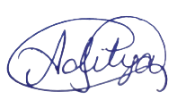
Signature of the student

Dated: 01/04/2026

